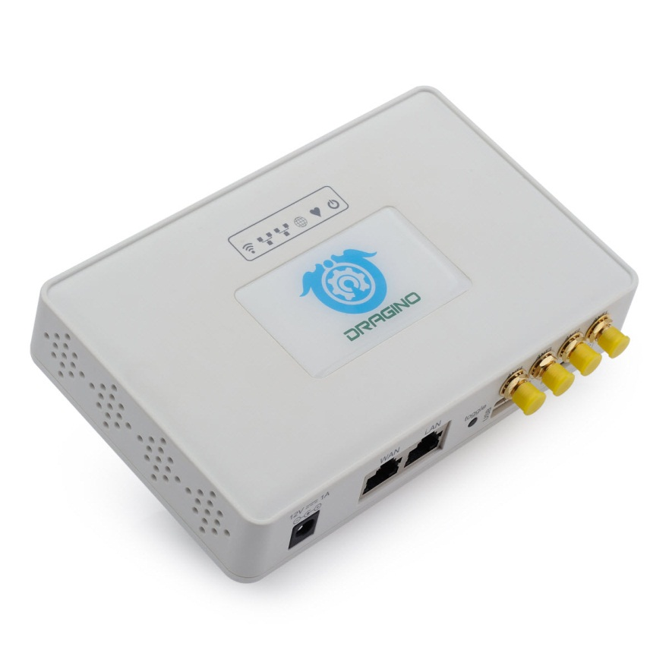

LG308 LoRaWAN Gateway User Manual
Document Version: 1.1.1
Firmware Version: LG02_LG08--build-v5.1.1542210480-20181114-2349

Version | Description | Date
1.0 | Release | 2018-Nov-17
1.1 | Add notice for recover mode. Add hardware source code  Add FAQ for customized frequency. | 2019-Jan-10
1.1.1 | Add how to control LED.

1. Introduction 4
1.1 What is LG08 & LG308 4
1.2 Specifications 4
1.3 Features 6
1.4 Hardware System Structure 6
1.5 LG308 Applications 7
2. Access LG308 8
2.1 Access and configure LG308 8
3. Typical Network Setup 9
3.1 Overview 9
3.2 Use WAN port to access Internet 9
3.3 Access Internet as a WiFi Client. 10
3.4 Use built-in 4G modem for internet access 12
3.5 Check Internet connection 14
4. Example : Configure as a LoRaWAN gateway 15
4.1 Create a gateway in TTN Server 15
4.2 Configure LG308 to connect to TTN 17
4.3 Configure frequency 18
4.4 Add a LoRaWAN End Device 19
5. Linux System 21
5.1 SSH Access for Linux console 21
5.2 Edit and Transfer files 22
5.3 File System 22
5.4 Package maintain system 23
6. Upgrade Linux Firmware 24
6.1 Upgrade via Web UI 24
6.2 Upgrade via Linux console 24
7. FAQ 25
7.1 How can I configure for customized frequency band? 25
7.2 Can I make my own firmware for LG308? Where can I find the source code of LG308? 29
7.3 Can I use the 868Mhz version for 915Mhz bands? 29
7.4 Can I control the LEDs? 29
7.5 More FAQs about general LoRa questions 29
8. Trouble Shooting 30
8.1 I get kernel error when install new package, how to fix? 30
8.2 How to recover the LG308 if firmware crash 31
8.3 I configured LG308 for WiFi access and lost its IP. What to do now? 32
9. Order Info 33
10. Packing Info 33
11. Support 33
12. Reference 35

- Introduction
  - What is LG08 & LG308

The LG308 is an open source LoRaWAN Pico Gateway. It lets you bridge LoRa wireless network to an IP network via WiFi, Ethernet, 3G or 4G cellular network. The LoRa wireless allows users to send data and reach extremely long ranges at low data-rates.
The LG308 is fully compatible with LoRaWAN protocol. It includes a SX1308 LoRa concentrator and a SX1276 LoRa tranceiver, the sx1308 provides 10 programmable parallel demodulation paths and the SX1276 acts as TX channel so the SX1308 won’t be block during TX. This combination provides higher capacity compare with a standalone SX1308 concentrator solution.

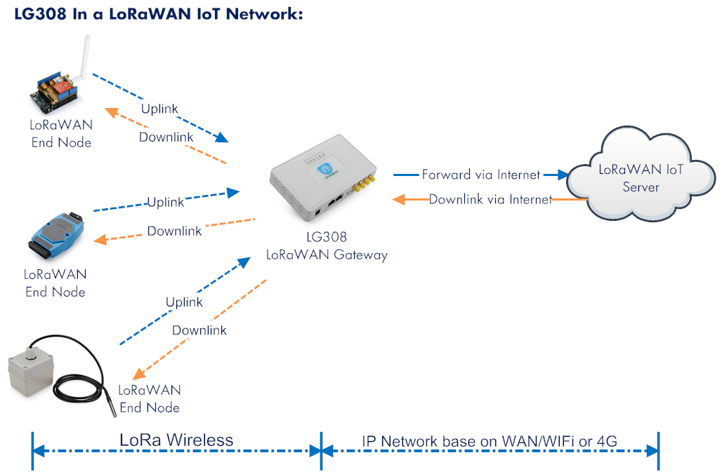

  - Specifications
Hardware System:
Linux Part:
- 400Mhz ar9331 processor
- 64MB RAM
- 16MB Flash

Interface:
- 10M/100M RJ45 Ports x 2
- WiFi : 802.11 b/g/n
- LoRaWAN Wireless
- Power Input: 12V DC, 1 A
- USB 2.0 host connector x 1
- Mini-PCI E connector x 1
- SX1308 + SX1276

WiFi Spec:
- IEEE 802.11 b/g/n
- Frenquency Band: 2.4 ~ 2.462GHz
- Tx power:
  - 11n tx power : mcs7/15: 11db mcs0 : 17db
  - 11b tx power: 18db
  - 11g 54M tx power: 12db
  - 11g 6M tx power: 18db
- Wifi Sensitivity
  - 11g 54M : -71dbm
  - 11n 20M : -67dbm
LoRa Spec:
- Up to -142.5dBm sensitivity with SX1257 Tx/Rx front-end
- 70 dB CW interferer rejection at 1 MHz offset
- Able to operate with negative SNR, CCR up to 9dB
- Emulates 49x LoRa demodulators and 1x (G)FSK demodulator
- Dual digital TX&RX radio front-end interfaces
- 10 programmable parallel demodulation paths
- Dynamic data-rate (DDR) adaptation
- True antenna diversity or simultaneous dual-band operation

Cellular 4G LTE (optional):
- Quectel EC25 LTE module
- Micro SIM Slot
- External 4G Sticker Antenna.
- Up to 150Mbps downlink and 50Mbps uplink data rates
- Worldwide LTE,UMTS/HSPA+ and GSM/GPRS/EDGE coverage
- MIMO technology meets demands for data rate and link reliability in modem wireless communication systems

  - Features
- Open Source OpenWrt system
- Managed by Web GUI, SSH via LAN or WiFi
- Emulates 49x LoRa demodulators
- LoRaWAN Gateway
- SX1276 base separate TX path
- 10 programmable parallel demodulation paths

  - Hardware System Structure

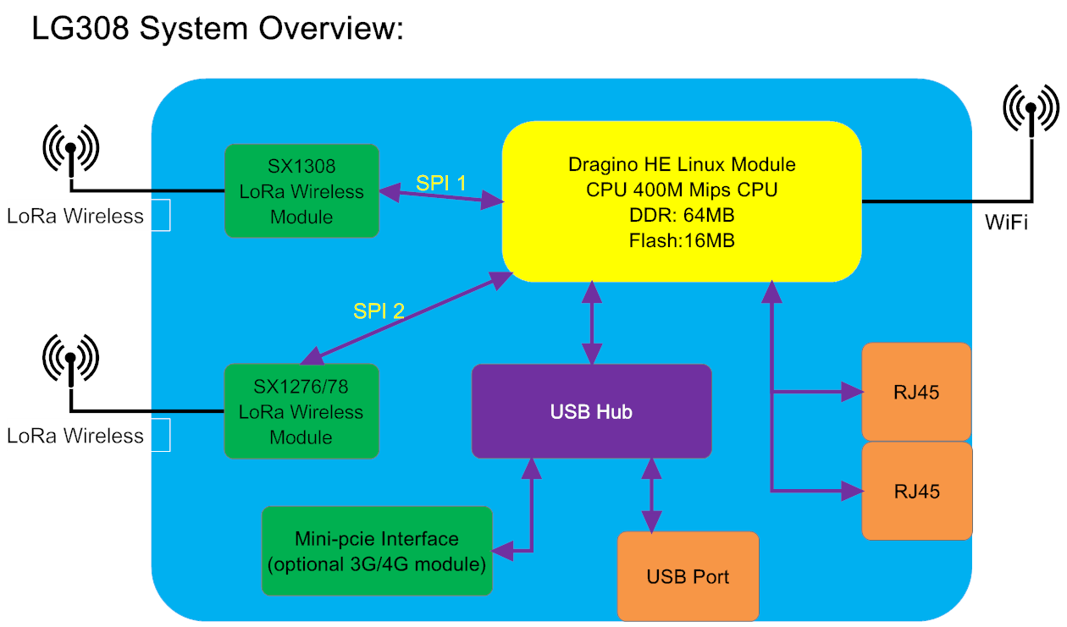

  - LG308 Applications

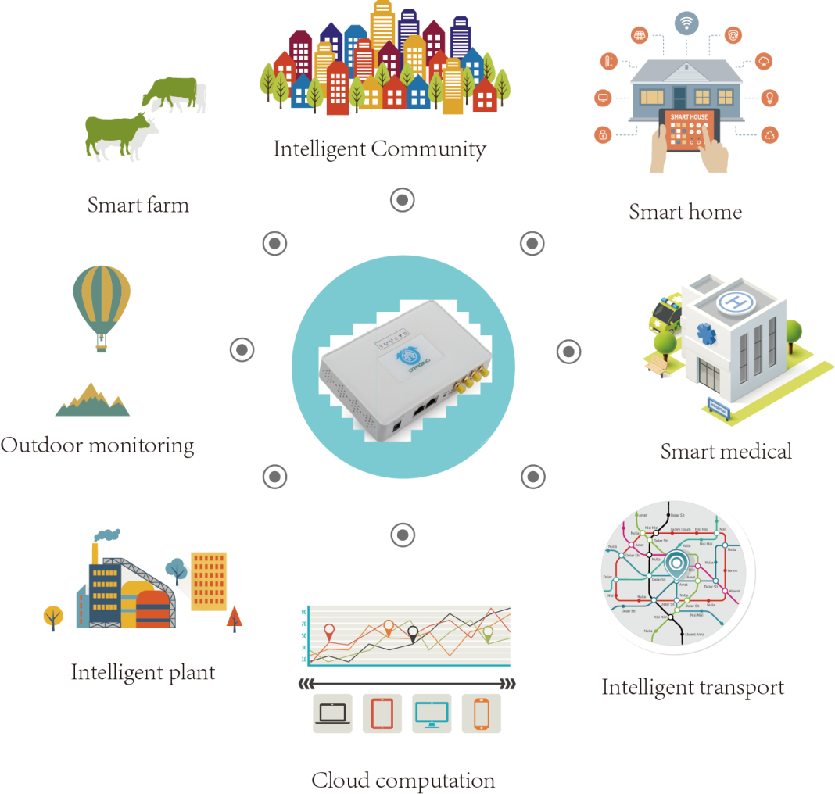

- Access LG308

  - Access and configure LG308
The LG308 is configured as a WiFi AP by factory default. User can access and configure the LG308 after connect to its WiFi network.
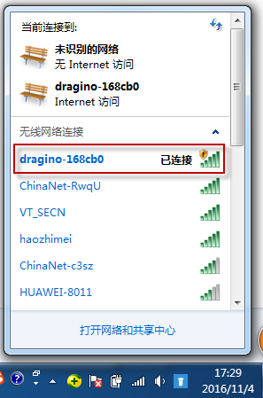
At the first boot of LG308, it will auto generate an unsecure WiFi network call dragino-xxxxxx

User can use the laptop to connect to this WiFi network. The laptop will get an IP address 10.130.1.xxx and the LG308 has the default IP 10.130.1.1

Open a browser in the laptop and type
http://10.130.1.1/
User will see the login interface of LG308.
The account for Web Login is:
User Name: root
Password: dragino
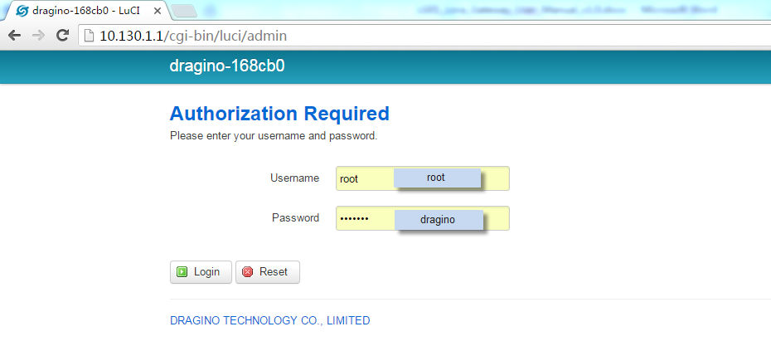
Notice: In case the WiFi network is disabled, user can connect PC to LG308’s LAN port, the PC will get DHCP from LG308, and be able to access it.

- Typical Network Setup
  - Overview
LG308 supports flexible network set up for different environment. This section describes the typical network topology can be set in LG308. The typical network set up includes:
- WAN Port Internet Mode
- WiFi Client Mode
- WiFi AP Mode
- USB Dial Up Mode

  - Use WAN port to access Internet
By default, the LG308 set to use WAN port as network connection. When connect LG308’s WAN port to router, LG308 will get IP from router and have internet access. The network status can be checked as below:
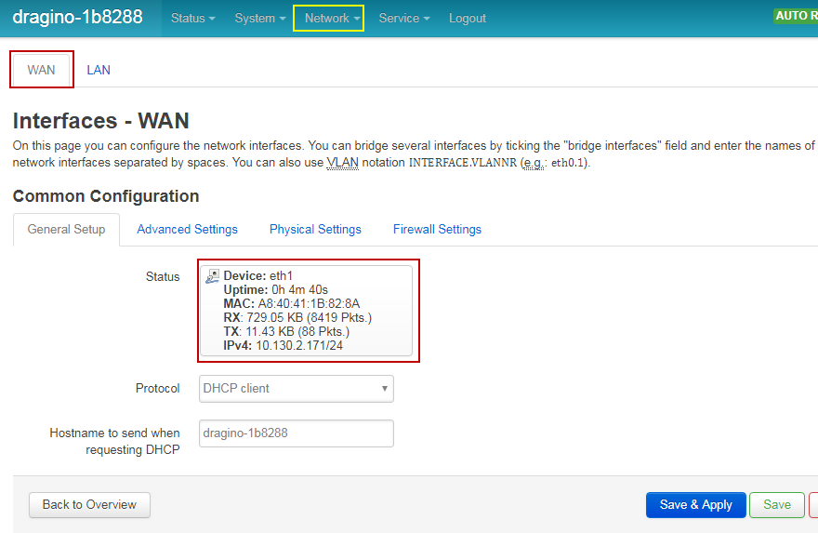

  - Access Internet as a WiFi Client.
In the WiFi Client Mode, Dragino acts as a WiFi client and gets DHCP from uplink router via WiFi.
The step to set is as below:

Step1:
In network -> Wireless, select Radio0 interface and scan.
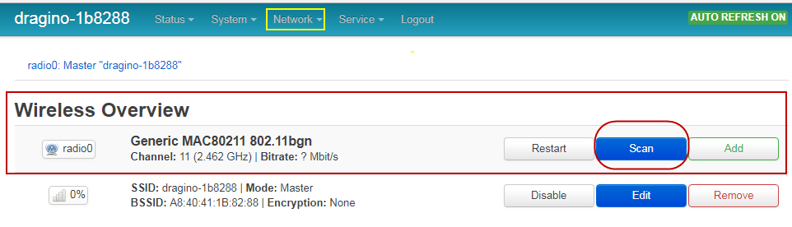

Step2:
Select the wireless AP and join:
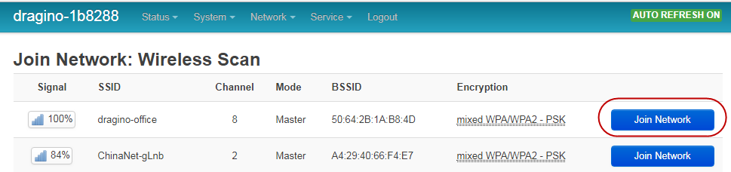

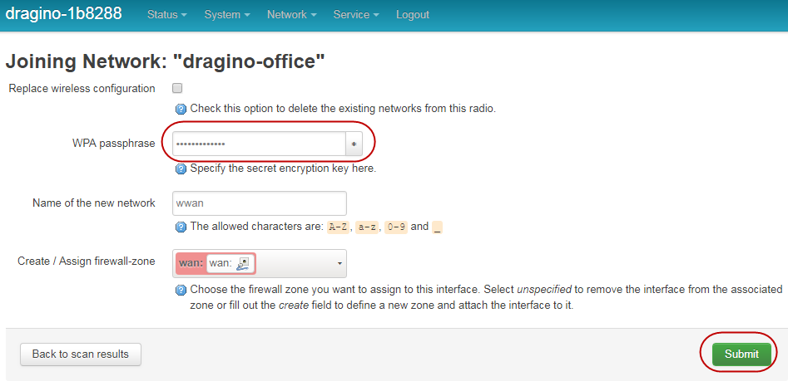

Step3:
In network->wireless page, disable WiFi AP network. Notice: After doing that, you will lose connection if your computer connects to the LG308 via LG308’s wifi network.
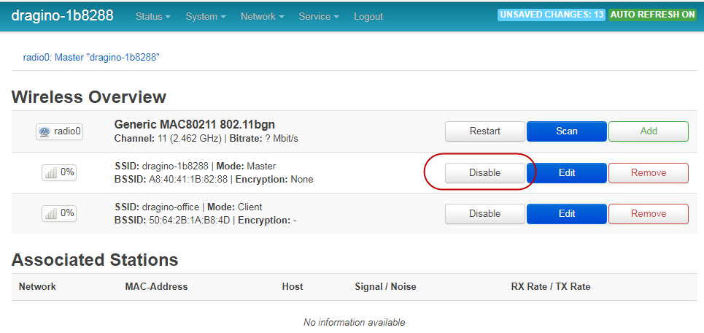

After successful associate, the WiFi network interface can be seen in the same page:
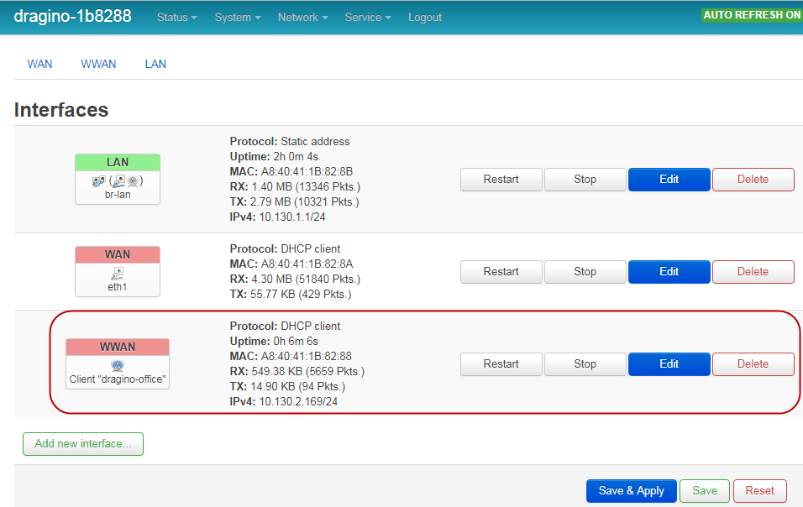

  - Use built-in 4G modem for internet access
For the LG308 model with 4G version, user can configure the modem for internet access.

Step 1: Add New Interface
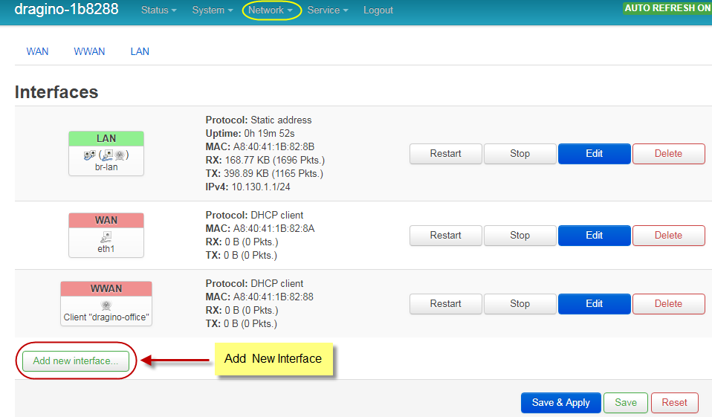
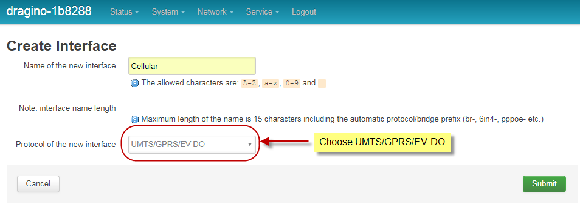

Step 2: Configure cellular interface
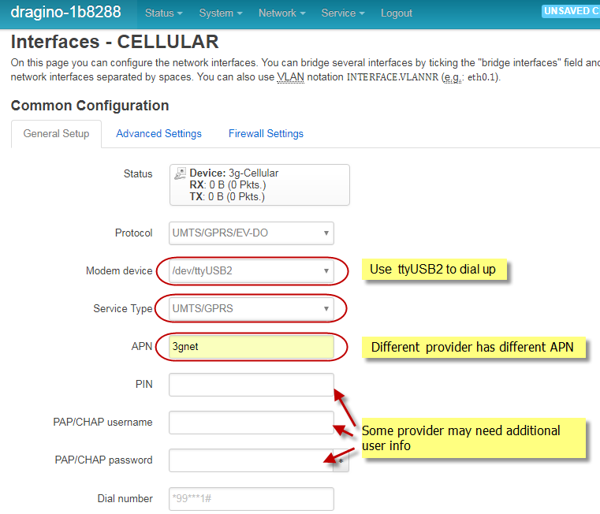

Step 3: Check Result
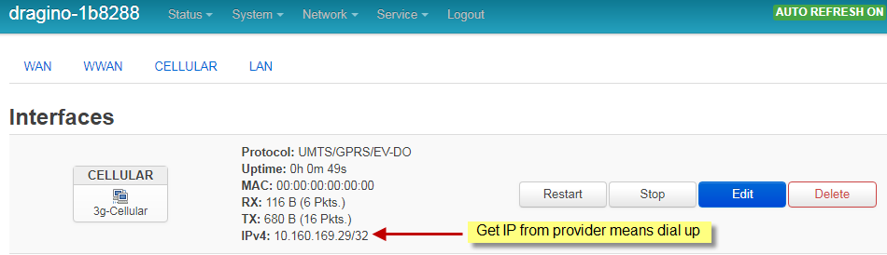

Note: In case you don’t know whether your device has 4G modem, you can run lsusb command in SSH access to check, as below:
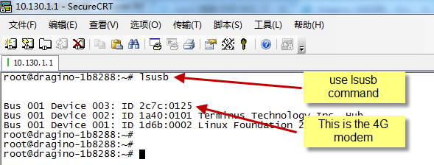

  - Check Internet connection
User can use the diagnostics page to check and analyze Internet connection.
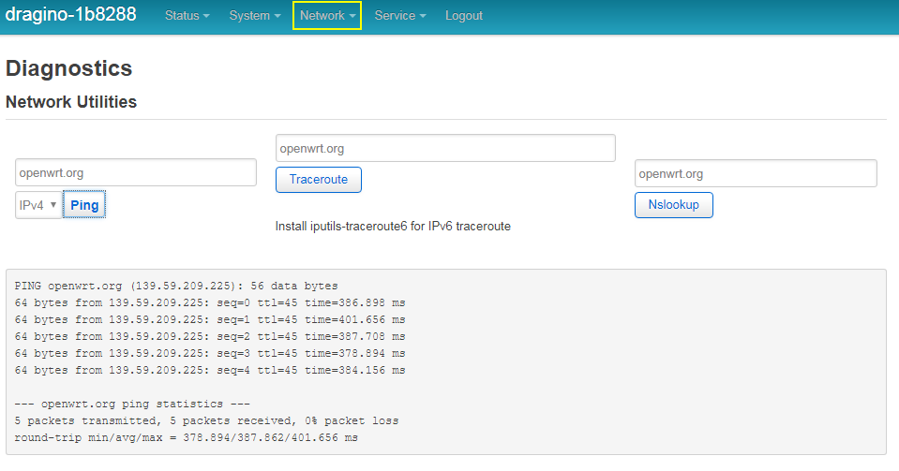

- Example : Configure as a LoRaWAN gateway
LG308 is fully compatible with LoRaWAN protocol. It use the legacy Semtech Packet forwarder to forward the LoRaWAN packets to server, the structure is as below.

This chapter describes how to use LG308 to work with TTN LoRaWAN Server. The method to work with other LoRaWAN server is similar.

  - Create a gateway in TTN Server
Step 1: Get a Unique gateway ID.
Every LG308 has a unique gateway id. The id can be found at LoRaWAN page:
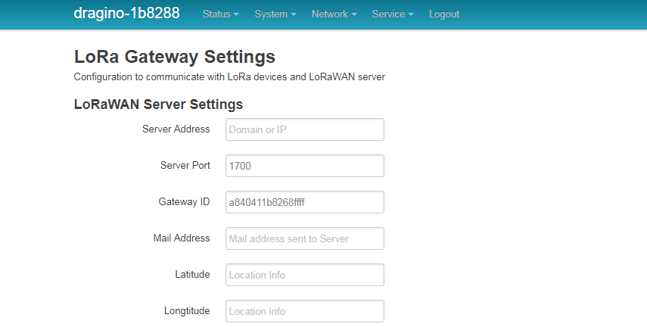

The gateway id is: a840411b8268ffff

Step 2: Sign up a user account in TTN server

Step 3: Create a Gateway
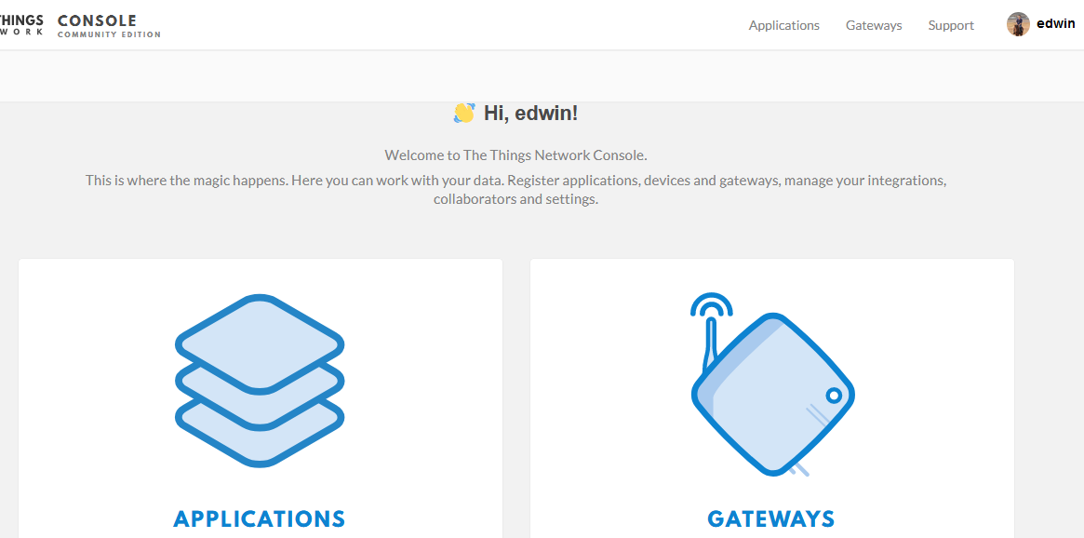

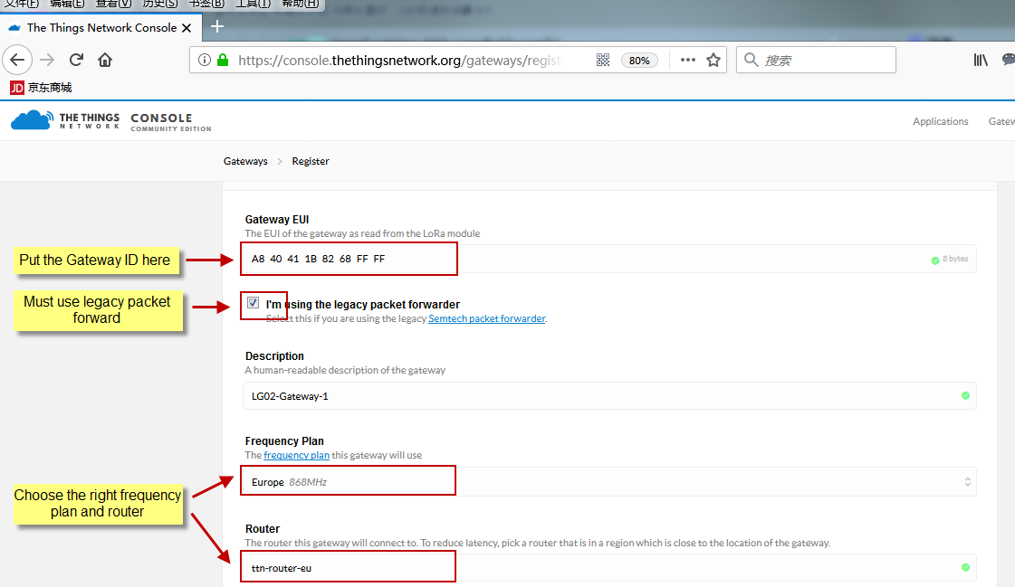

After create the gateway, we can see the gateway info, as below
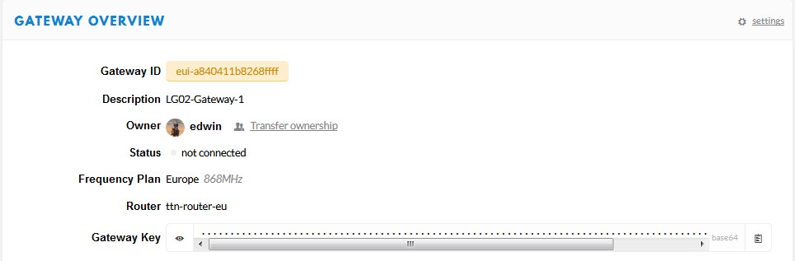

  - Configure LG308 to connect to TTN
We should configure the LG308 now to let it connect to TTN network. Make sure your LG308 has Internet Connection first.

Step1: Configure LG308 to act as raw forwarder
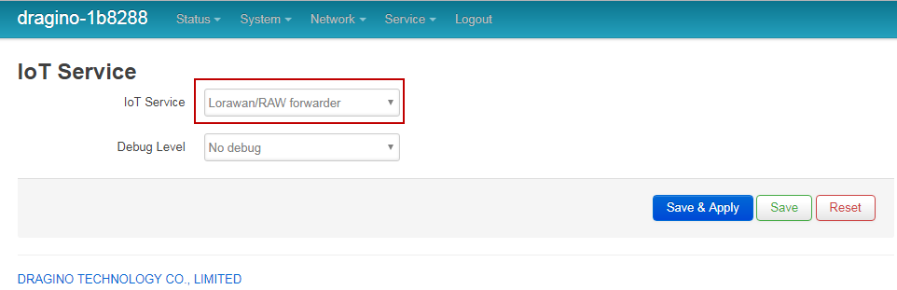

Step2: Input server info and gateway id
Choose the correct the server address and gateway ID.
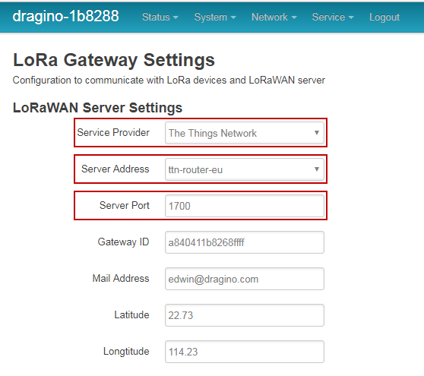

Check Result
After above settings, the LG308 should be able to connect to TTN, below is the result seen from TTN:
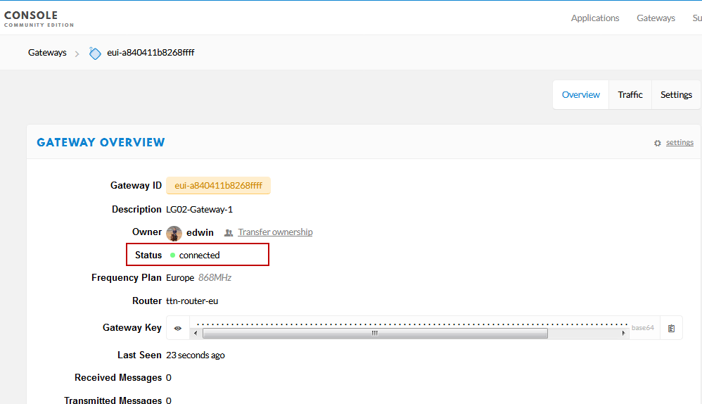

  - Configure frequency
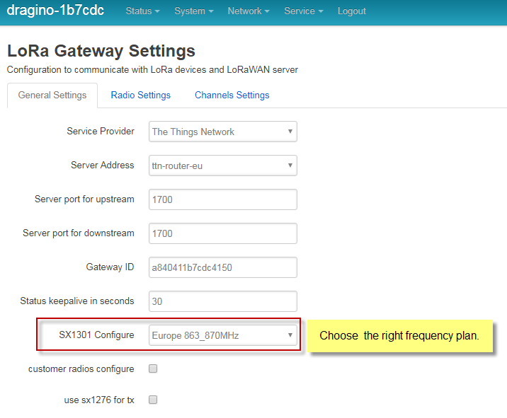

After doing above LG308 will be able to act as LoRaWAN. Below section shows how to add a LoRaWAN End device in this LoRaWAN network and see the data from TTN.
We use LT-33222-L as a reference below, for other LoRaWAN devices will be more or less the same.

  - Add a LoRaWAN End Device
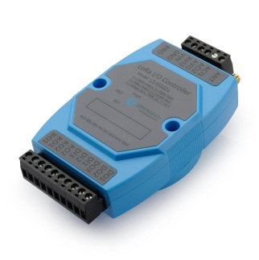
Step 1: Create a device in TTN with the OTAA keys from LT IO controller.
Each LT is shipped with a sticker with the default device EUI as below:
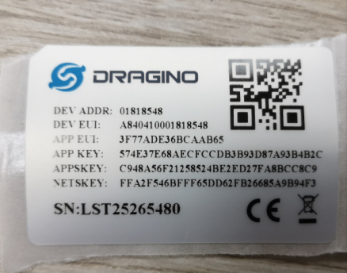

User can enter this key in their LoRaWAN Server portal. Below is TTN screen shot:
Add APP EUI in the application.
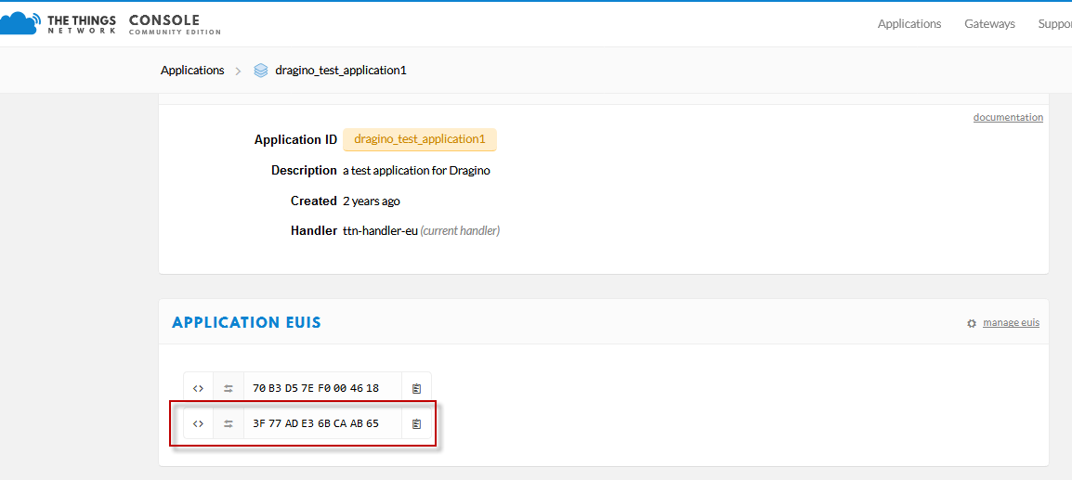
Add APP KEY and DEV EUI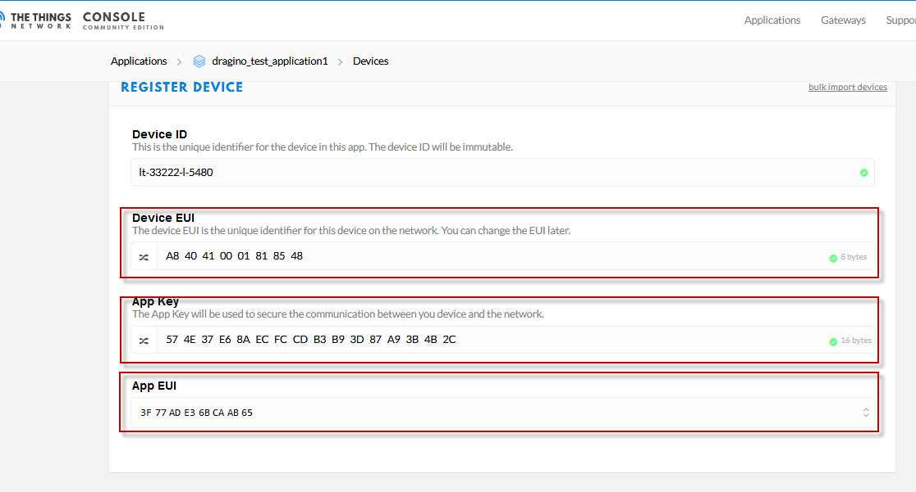

Step 2: Power on LT and it will auto join to the TTN network. After join success, it will start to upload message to TTN and user can see in the panel and analyze the data
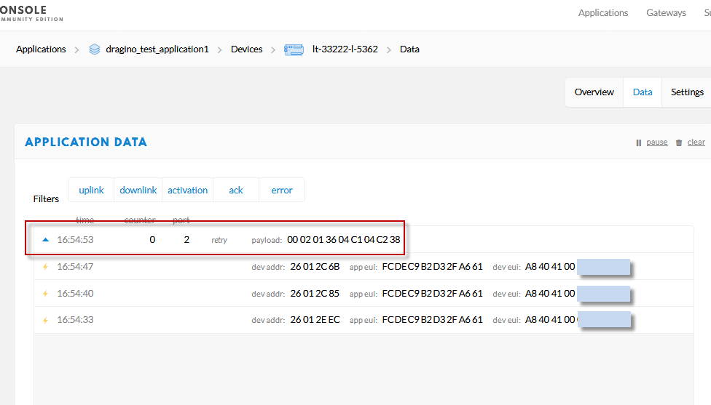

- Linux System
The LG308 bases on OpenWrt Linux System. It is open source, and user are free to configure and modify the inside Linux settings.
  - SSH Access for Linux console
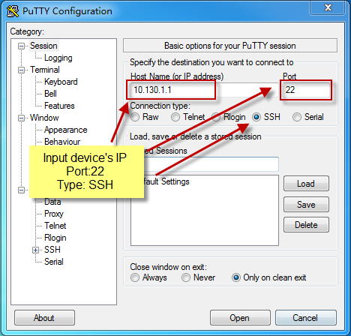
User can access to the Linux console via SSH protocol. Make sure your PC and the LG01 is in the same network, then use a SSH tool (such as putty) to access it. Below are screenshots:

IP address: IP address of LG308
Port: 22
User Name: root
Password: dragino (default)

After log in, you will be in the Linux console and type command here.
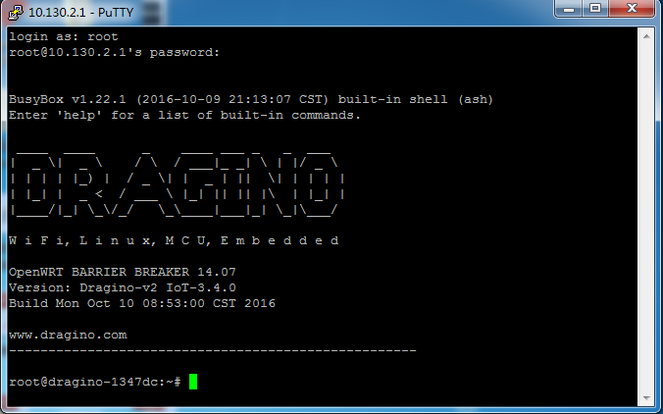

  - Edit and Transfer files
The LG308 support SCP protocol and has a built SFTP server. There are many ways to edit and transfer files using these two protocols. One of the easiest is through WinSCP utility. After access via WinSCP to the device, use can use a FTP alike window to drag / drop files to the LG308 or Edit the files directly in the windows. Screenshot is as below:
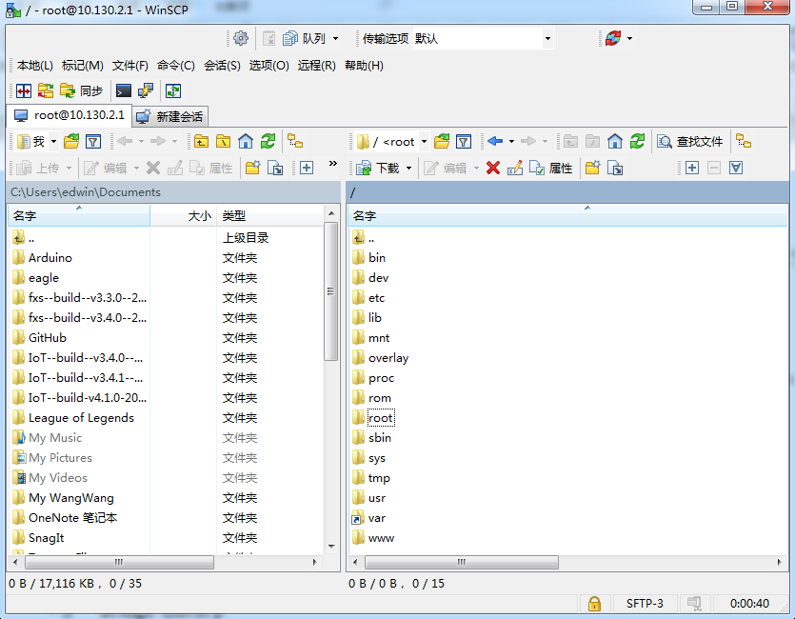

  - File System
The LG308 has a 16MB flash and a 64MB RAM. The /var and /tmp directory are in the RAM, contents stored in /tmp and /var will be erased after reboot the device. Other directories are in the flash and will keep after reboot.

The Linux system use around 8MB ~10MB flash size which means there is not much room for user to store data in the LG308 flash. User can use an external USB flash to extend the size for storage.

  - Package maintain system
LG308 uses OPKG package maintain system. There are more than 3000+ packages available in our package server for user to install for their applications. For example, if user wants to add iperf tool, they can install the related packages and configure LG308 to use iperf

Below is some examples opkgs command, more please refer OPKG package maintain system

In Linux Console run:
root@dragino-169d30:~# opkg update // to get the latest packages list
root@dragino-169d30:~# opkg list //shows the available packages
root@dragino-169d30:~# opkg install iperf // install iperf, it will auto install the required packages.
root@dragino-169d30:/etc/opkg# opkg install iperf
Installing iperf (2.0.12-1) to root...
Downloading http://downloads.openwrt.org/snapshots/packages/mips_24kc/base/iperf_2.0.12-1_mips_24kc.ipk
Installing uclibcxx (0.2.4-3) to root...
Downloading http://downloads.openwrt.org/snapshots/packages/mips_24kc/base/uclibcxx_0.2.4-3_mips_24kc.ipk
Configuring uclibcxx.
Configuring iperf.

- Upgrade Linux Firmware
We keep improving the LG308 Linux side firmware for new features, bug fixes. The latest firmware can be found on LoRa Gateway Firmware, and the Change Log can be found here: Firmware Change Log.

The file named as xxxxx--xxxxx-squashfs-sysupgrade.bin is the upgrade Image. There are different methods to upgrade, as below:
  - Upgrade via Web UI
Go to the page: Web --> System --> Back Up and flash firmware, Select the image and click Flash Image, the image will be uploaded to the device and then click Process Update to upgrade.

System will auto boot to the new firmware after upgrade.
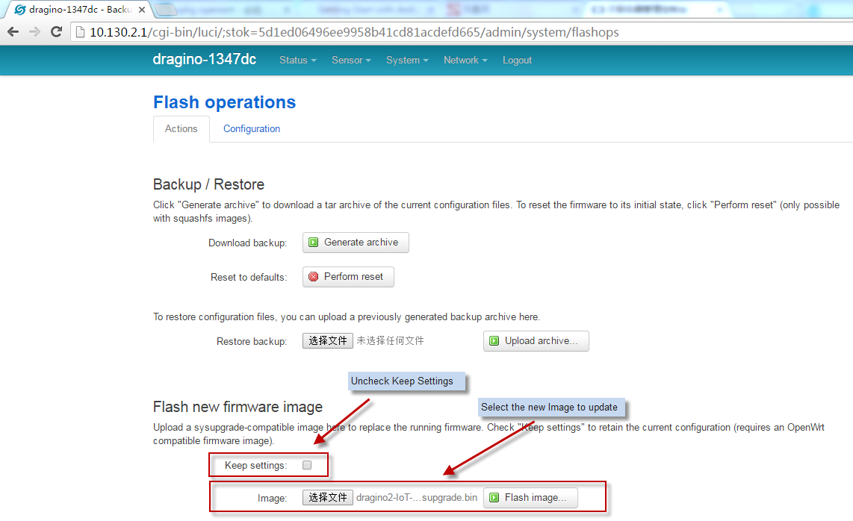

  - Upgrade via Linux console

SCP the firmware to the system /var directory and then run
root@OpenWrt:~# /sbin/sysupgrade -n /var/Your_Image
note: it is important to transfer the image in the /var directory, otherwise it may exceed the flash size.

- FAQ
  - How can I configure for customized frequency band?
User can customized their LoRaWAN channel since firmware after 2018-Dec-28.
For example: if user want to set the gateway to meet the India LoROIT frequency band:
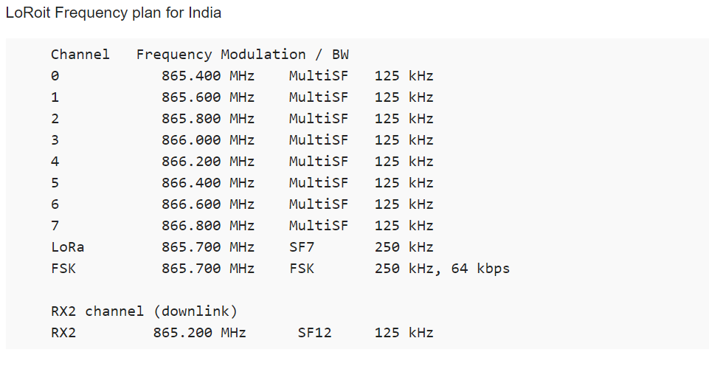
Step 1: Choose Frequency Band to use “Customized Bands”
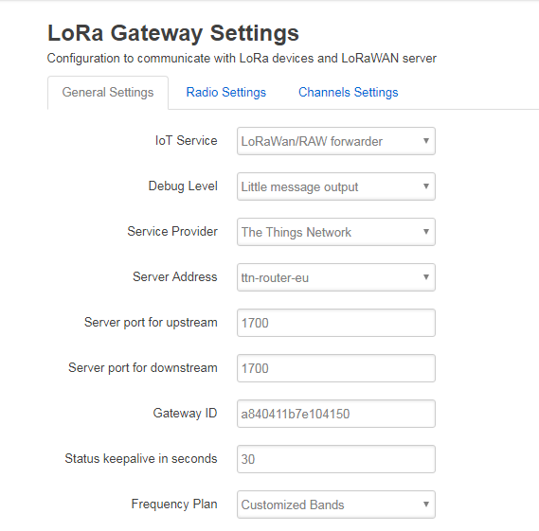

Step 2: Configure Radio 0 & 1 Frequency
The LG308 has two Radios from SX1308, we can configure these eights channels base on these two radios. Go to page Radio Settings and enable Radio 0 to 865700000 / enable Radio 1 to 866500000.
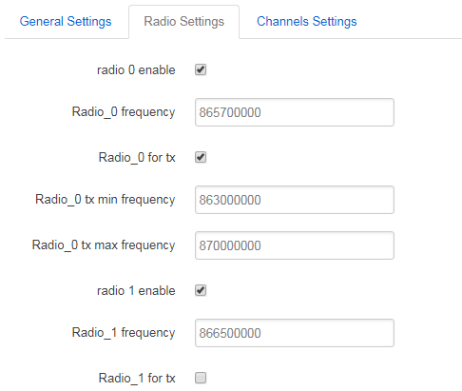

Step 3: Configure Channel Frequency.
What we need to configure for LoRoit is 0~7 multiSF channel frequency and LoRa frequency as per LoRiot frequency plan.
Each Channel Configure include below parameters:
- Radio used for this channel.
- Channel IF, frequency shift base on Radio Frequency.

Below is the settings for the LoRiot frequency plan:
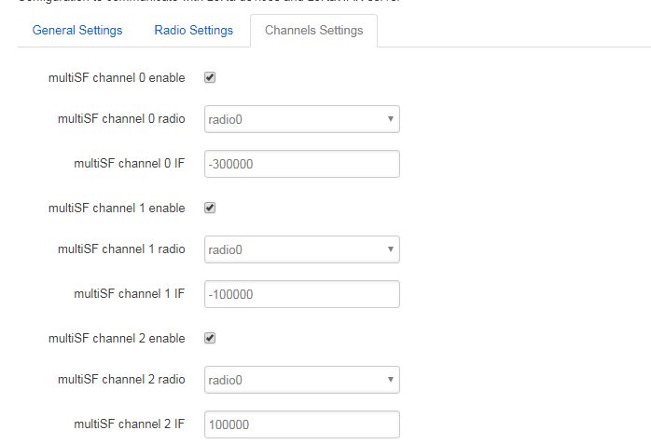
Channel 2 frequency= 865.8Mhz
Channel 1 frequency= 865.6Mhz
Channel 0 frequency=radio0 – 300000Hz
= 865700000-300000 = 865.4Mhz
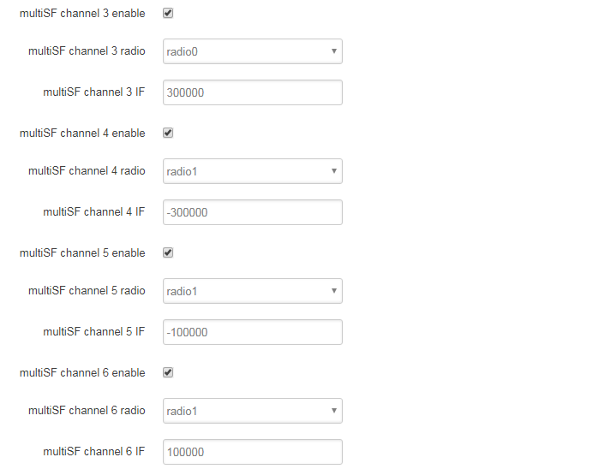
Channel 6 frequency= 866.6Mhz
Channel 5 frequency= 866.4Mhz
Channel 4 frequency= 866.2Mhz
Channel 3 frequency= 866.0Mhz
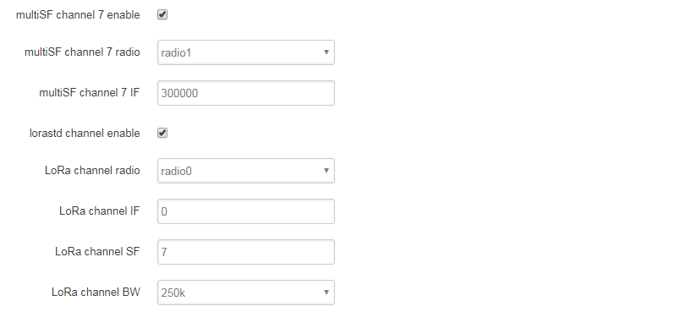
Channel LoRaSTD frequency= 865.7Mhz, SF7, BW250Khz
Channel 7 frequency= 866.8Mhz

Step 4: Save & Apply & check result in logread page.
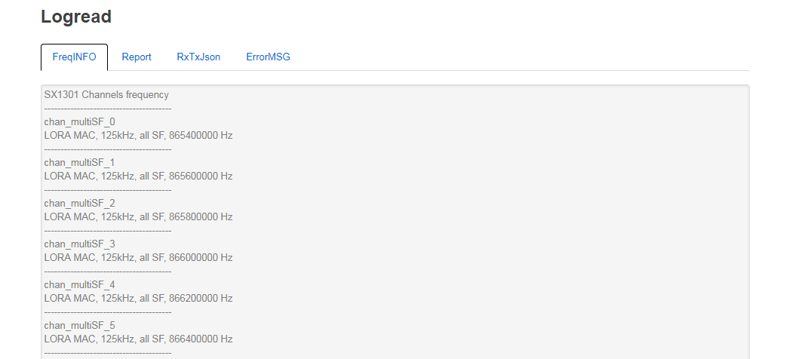

  - Can I make my own firmware for LG308? Where can I find the source code of LG308?
Yes, User can make own firmware for LG308 for branding purpose or add customized application.
The LG308 source code and compile instruction can be found at: https://github.com/dragino/openwrt_lede-18.06

  - Can I use the 868Mhz version for 915Mhz bands?
It is possible, you can select US915 frequency band in 868Mhz version hardware, it will work but you will see performance is highly decrease because the 868Mhz version has RF filter for band 863~870Mhz, all other frequency will have high attenuation.

  - Can I control the LEDs?
Except the PWR LED is controlled by +3v3 power directly. All other LEDs can be controlled by developer.

Control Globe LED:
ON: echo 1 > /sys/class/leds/dragino2\:red\:wlan/brightness
OFF: echo 0 > /sys/class/leds/dragino2\:red\:wlan/brightness

Control HEART LED:
First export the gpio27 and set to out
echo 27 > /sys/class/gpio/export
echo out > /sys/class/gpio/gpio27/direction
ON: echo 0 > /sys/class/gpio/gpio27/value
OFF: echo 1 > /sys/class/gpio/gpio27/value

  - More FAQs about general LoRa questions
We keep updating more FAQs in our WiKi about some general questions. The link is here:
http://wiki.dragino.com/index.php?title=LoRa_Questions

- Trouble Shooting
  - I get kernel error when install new package, how to fix?
In some case, when install package, it will generate kernel error such as below:
root@dragino-16c538:~# opkg install kmod-dragino2-si3217x_3.10.49+0.2-1_ar71xx.ipk
Installing kmod-dragino2-si3217x (3.10.49+0.2-1) to root...
Collected errors:
* satisfy_dependencies_for: Cannot satisfy the following dependencies for kmod-dragino2-si3217x:
* kernel (= 3.10.49-1-4917516478a753314254643facdf360a) *
* opkg_install_cmd: Cannot install package kmod-dragino2-si3217x.

In this case, user can use the –force-depends option to install such package.
opkg install kmod-dragino2-si3217x_3.10.49+0.2-1_ar71xx.ipk --force-depends

  - How to recover the LG308 if firmware crash
LG308 provide user a full control on its Linux system, it is possible that the device will brick and can’t boot after improper modification in some booting files.

In this case, user can recover the whole Linux system by uploading a new firmware via Web Failsafe mode.

Procedure is as below:
- Use a RJ45 cable to connect the PC to LG308’s port directly.
- Set the PC to ip 192.168.255.x, netmask 255.255.255.0
- Pressing the toggle button and power on the device
- All LEDs of the device will blink, release the toggle button after four blinks
- All LEDs will then blink very fast once, this means device detect a network connection and enter into the web-failsafe mode. Your PC should be able to ping 192.168.255.1 after device enter this mode.
- Open 192.168.255.1 in web broswer
- Select a squashfs-sysupgrade type firmware and update firmware.
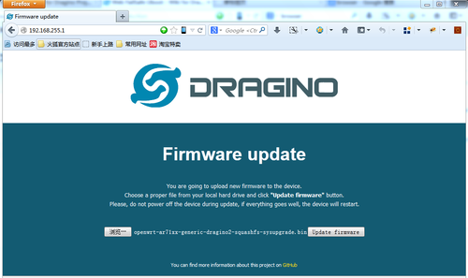

Note: If user sees all LEDs blink very fast in Step 5. This means the network connection is established. If in this case, PC still not able to see the web page, user can check:
- Try different browser.
- Check if your PC is in 192.168.255.x
- Check if you have connected two RJ45 cable to device, If so, remove the unused one

  - I configured LG308 for WiFi access and lost its IP. What to do now?
The LG01 has a fall-back ip in its LAN port. This IP is always enabled so user can use fall back ip to access LG01 no matter what the WiFi IP is. The fall back ip is useful for connect and debug the unit.
(Note: fallback ip can be disabled in the LAN and DHCP page)
Steps to connect via fall back IP:
- Connect PC’s Ethernet port to LG01’s LAN port
- Configure PC’s Ethernet port has IP: 172.31.255.253 and netmask: 255.255.255.252
As below photo:
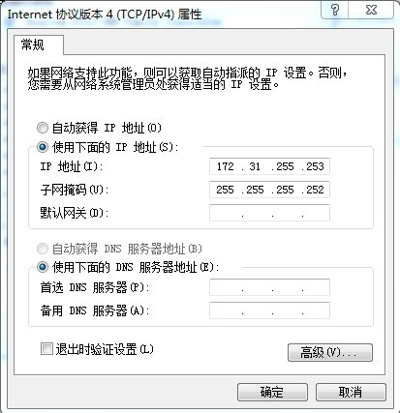
- In PC, use 172.31.255.254 to access LG01 via Web or Console.

- Order Info

PART: LG308-XXX-YYY:
XXX: Frequency Band
- 868: valid frequency: 863Mhz ~ 870Mhz. for band EU868 or IN865.
- 915: valid frequency: 902Mhz ~ 928Mhz. for bands US915, AU915, AS923 or KR920

YYY: 4G Cellular Option
- EC25-E: EMEA, Korea, Thailand, India.
- EC25-A: North America/ Rogers/AT&T/T-Mobile.
- EC25-AU: Latin America, New Zeland, Taiwan
- EC25-J: Japan, DOCOMO/SoftBank/ KDDI
More info about valid bands, please see EC25-E product page.

- Packing Info
Package Includes:
- LG308 or LG08 LoRa Gateway x 1
- Stick Antenna for LoRa RF part. Frequency is one of 433 or 868 or 915Mhz depends the model ordered
- Power Adapter: EU/AU/US type power adapter depends on country to be used
- Packaging with environmental protection paper box

Dimension and weight:
- Device Size: 12 x 8.5 x 3 cm
- Device Weight: 150g
- Package Size / pcs : 21.5 x 10 x 5 cm
- Weight / pcs : 360g
- Carton dimension: 45 x 31 x 34 cm. 36pcs per carton
- Weight / carton : 12.5 kg

- Support
- Try to see if your questions already answered in the wiki.
- Support is provided Monday to Friday, from 09:00 to 18:00 GMT+8. Due to different timezones we cannot offer live support. However, your questions will be answered as soon as possible in the before-mentioned schedule.
- Provide as much information as possible regarding your enquiry (product models, accurately describe your problem and steps to replicate it etc) and send a mail to
support@dragino.com

- Reference
- Source code for LG08 LoRa Gateway
https://github.com/dragino/openwrt_lede-18.06

- OpenWrt official Wiki
http://www.openwrt.org/

- Firmware
http://www.dragino.com/downloads/index.php?dir=LoRa_Gateway/LG308-OLG308/Firmware/

- Hardware Source code:
https://github.com/dragino/motherboard-hardware/tree/master/LG308

